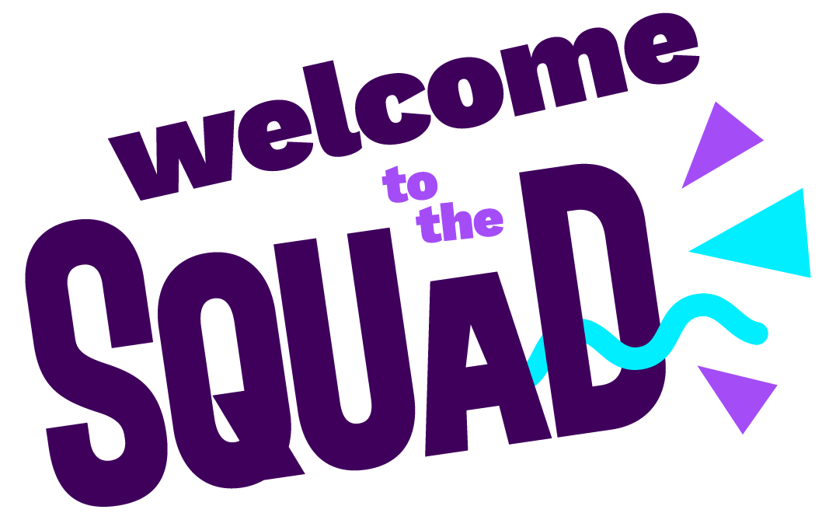

SQUAD LEADER APPLICATION FORM

Hi, we’re Music Squad
…and we’re on a mission to kick some serious life into learning a musical instrument! Music Squad exists to share the joy, friendship and adventure that music can bring to all children and we’re on the look out for fun, passionate and enthusiastic musicians to bring our mission to life.
Thank you for your interest in joining the Music Squad team. Please return the completed form with your CV to Hannah at hannah@musicsquad.co.uk.

Basic Information

Full Name: | Address:
Email:

Phone:

Do you have a clean current Driving Licence? YES/NO (If no, give details below)

Do you have access to a car? YES/NO

Have you had a DBS check in the last year? YES/NO

Have you joined the DBS update service? YES/NO

Have you ever been convicted of a criminal offence (other than spent convictions as detailed in the Rehabilitation of Offenders Act 1964?) (If yes, give details below) YES/NO

Experiences

Please detail any experience you think relevant to your application for this job.

Please detail any musical qualifications or experiences you have.

Please explain why you would like to join the Music Squad team.

What are your 3 biggest strengths (left) and 3 things to work on (right)?
1. | 1.
2. | 2.
3. | 3.

Availability

How many days per week would you like to work?

Please tick the times you are free to work:

Monday | Morning | Afternoon
Tuesday | Morning | Afternoon
Wednesday | Morning | Afternoon
Thursday | Morning | Afternoon
Friday | Morning | Afternoon
Please detail the areas you are happy to work in (we currently work in schools across Cheshire East and South Manchester inc. Altrincham/Sale area).

References

Please give details of two references. Referees must have known you for at least three years and at least one should have been an employer.
1

Full Name: | Company:
Position or Title: | Relationship to You:
Email: | Phone:

2

Full Name: | Company:
Position or Title: | Relationship to You:
Email: | Phone:

If you are not an EU national, do you have permission to work in the UK? YES/NO

If yes, you will need to produce evidence of your entitlement to work in the UK.

Thank you so much for your time. Please return to Hannah at hannah@musicsquad.co.uk

